# **Application Flow**

Belowlist ofdiagram gives the overview of application flow. As application is hosted in EC2 instance of Amazon Web services, use below link to access the application

<http://52.32.177.107:8080/InstagramUserPics/>

* Select the Instagram user from the drop down for which user uploaded images can be downloaded.

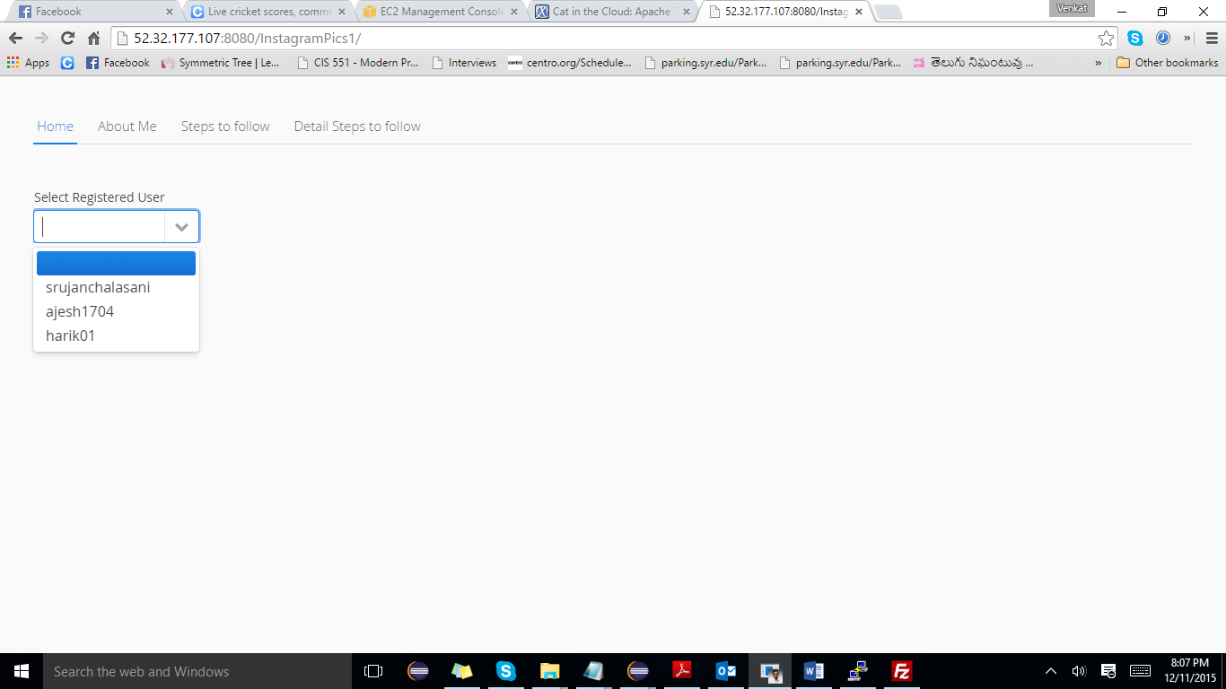

* On selecting the user, a JSON file will be downloaded by consuming Instagram REST service which is created with the help of selected user, access token. File path is displayed to user to access if the application ran on local server

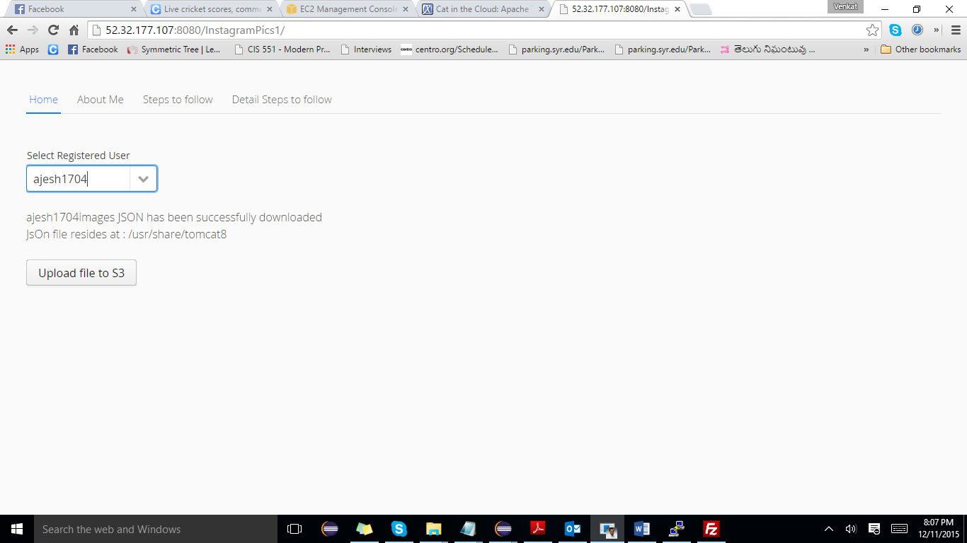

* On clicking the Upload file to S3 button the JSON file is uploaded to S3 and will be stored in the venkatacaproject bucket (it doesn’t make difference to logical flow). Please go to next step.

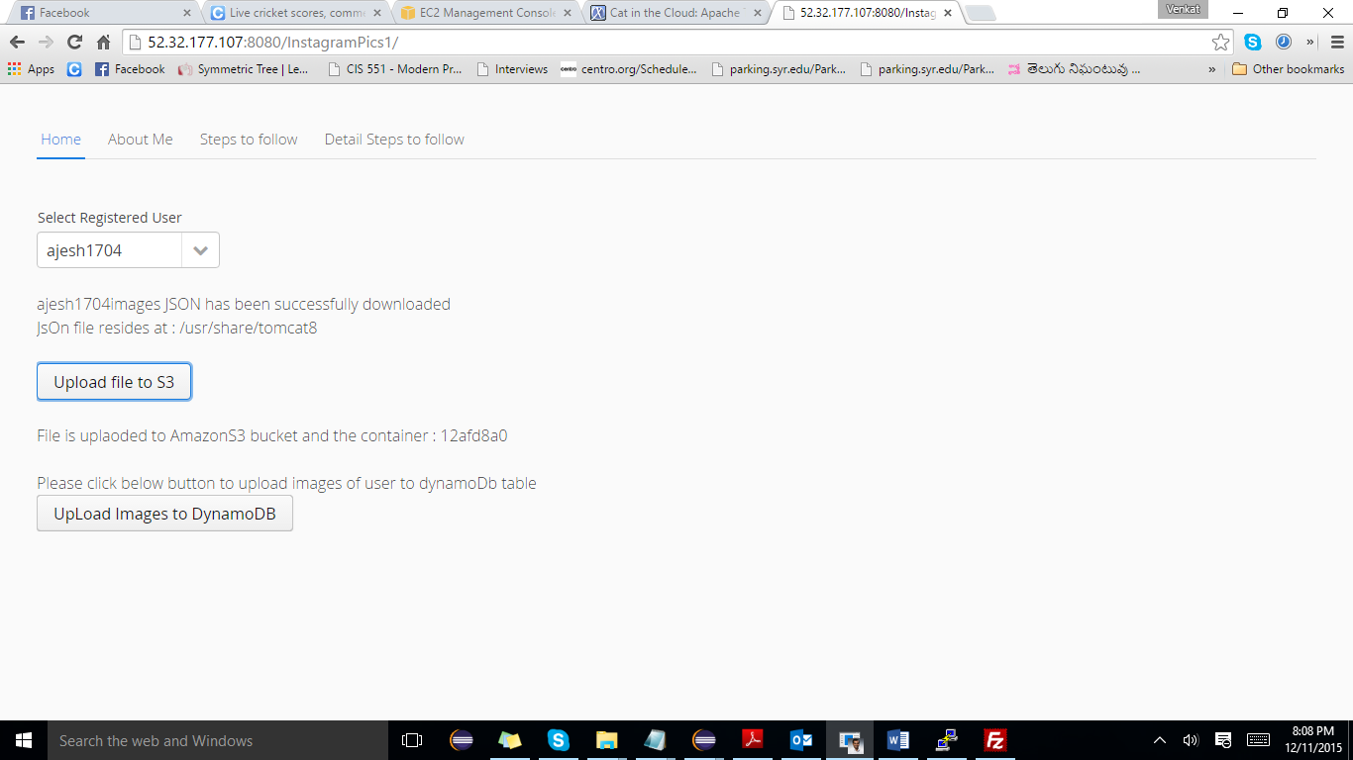

* On clicking the upload images to Dynamo DB, the JSON file that is stored in S3 is parsed and the URL of the image will be added to the Data Base

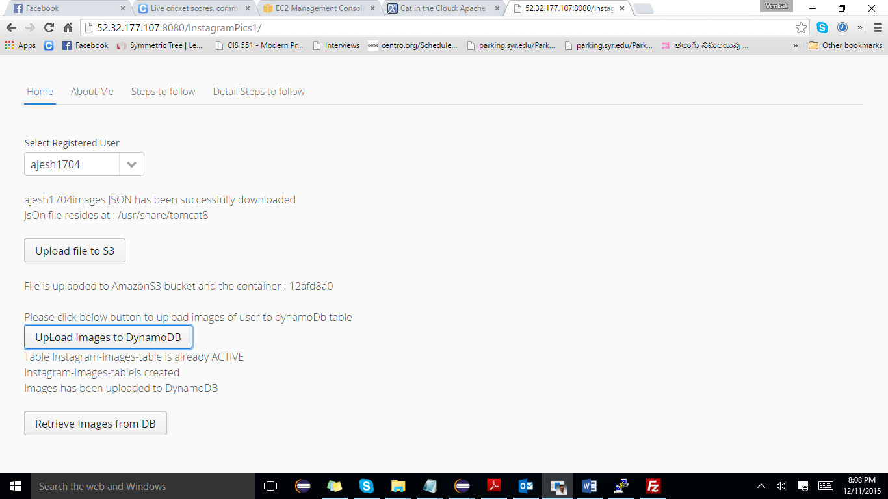

* On clicking the Retrieve image button the images from the Data Base will be retrieved and the URLS will be displayed on to the screen

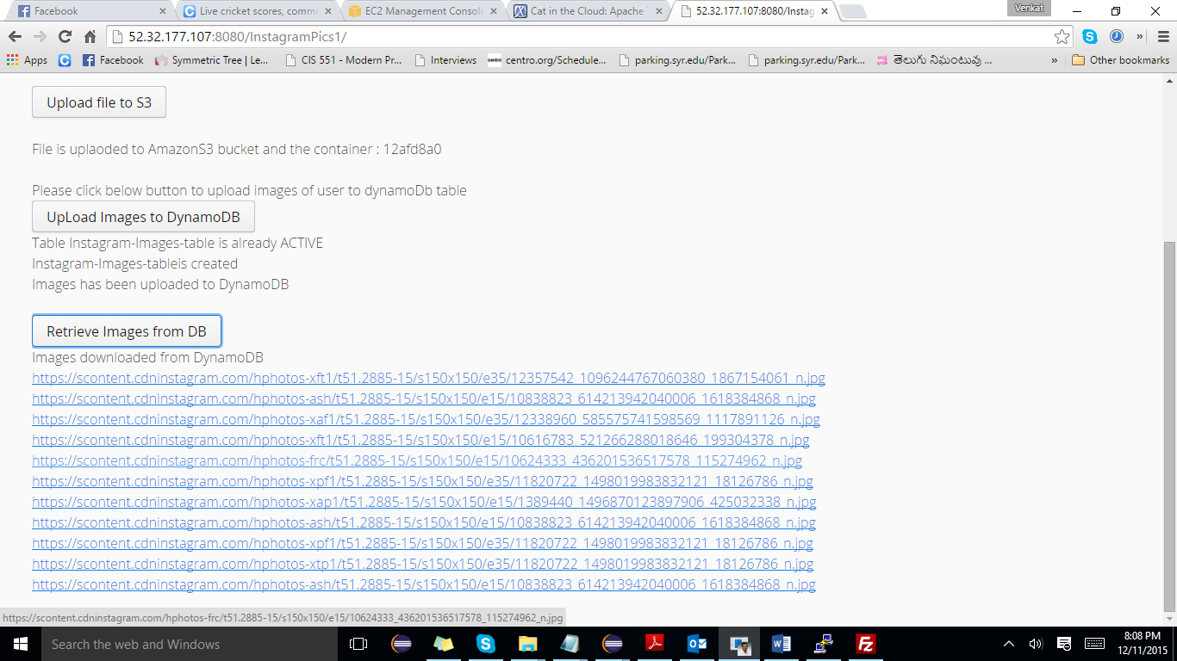

* On clicking the image URLS the images will be displayed to the user

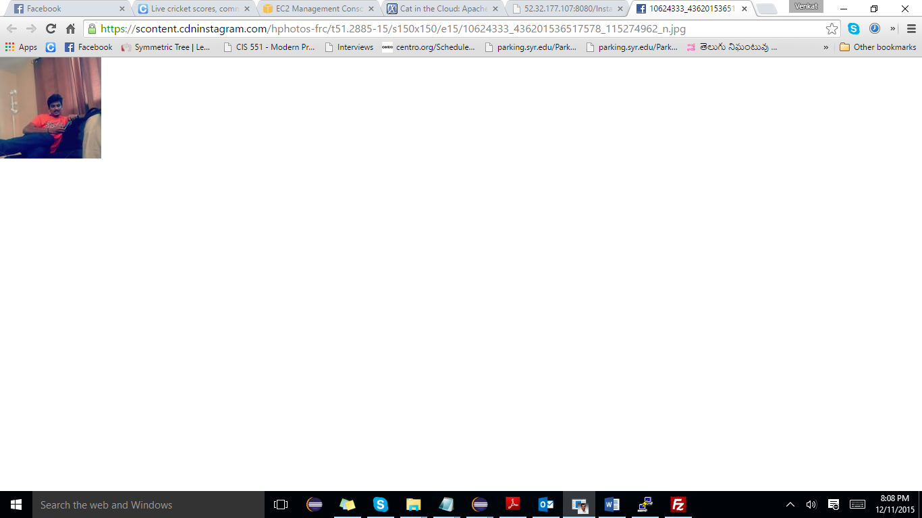

**Steps to execute Location Pics search**

Enter latitude and longitude coordinates to search for images and click on Download images.

If no images are present in the given coordinates, it displays the coordinates where the images are present.

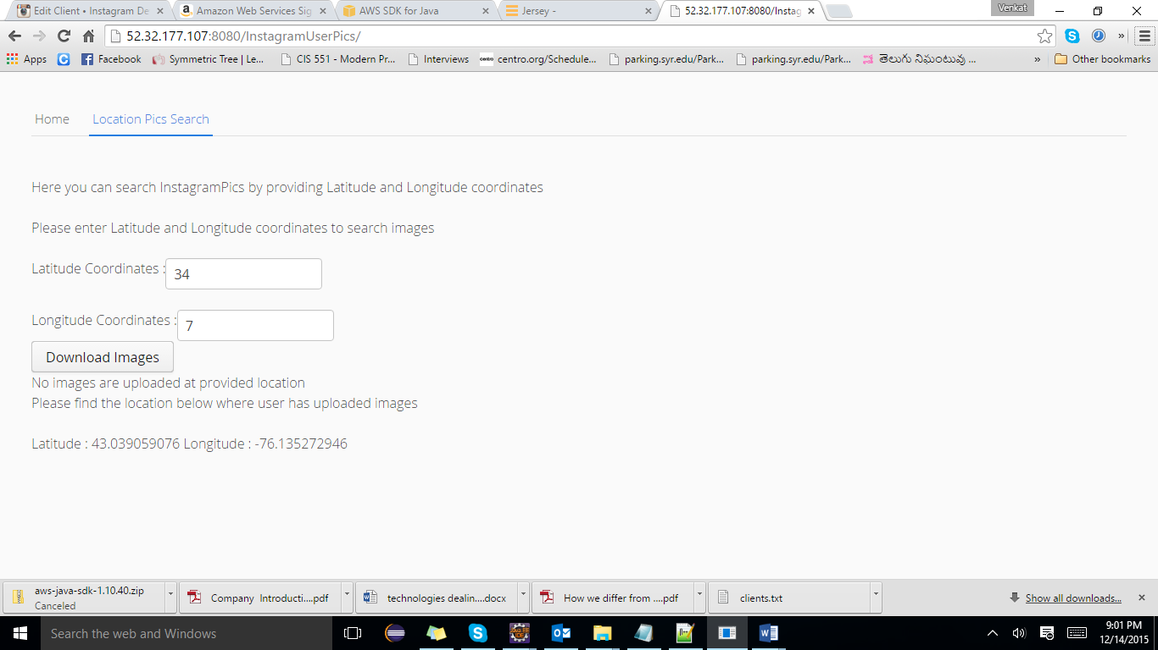

If you want to view the images at given location, please enter those coordinates.

